- This week's volatility in gilt yields highlighted the risk that political developments could trigger an abrupt loss of market confidence. The UK is particularly vulnerable to this scenario because of the poor state of the public finances. As we highlighted in a recent note, very low levels of net immigration risk making the fiscal arithmetic even more challenging for the government.
- GDP grew by just 0.1% q/q in Q4 2025, matching the underwhelming performance of Q3. The outturn would have been even worse without another strong contribution from the public sector. With no sign of a sustainable private sector growth driver emerging, we're unlikely to see GDP growth top 1% in 2026.
For some time, we've been warning that the fragile state of the UK's public finances leaves it vulnerable to a scenario where political developments trigger a sudden loss of market confidence. This week's events offered a good demonstration of that risk. On Monday, Anas Sarwar, Labour's leader in Scotland, called for Keir Starmer to stand down as Prime Minister due to Starmer's role in the Mandelson scandal. Coming on the back of mounting criticism of the PM, the 10-year gilt yield rose almost 10bp intraday. That move subsequently reversed when every member of the cabinet provided public backing to the PM.
But with a series of potential problems to navigate over the next few months, the period of calm will probably prove temporary. The government has been forced to agree to release thousands of documents related to Mandelson's appointment as UK ambassador to the US, which could bring fresh revelations. Labour seems likely to lose the Gorton and Denton by-election on February 26 – bookmakers currently make them third favourites, well behind the Greens and Reform. And Labour's poor poll ratings suggest it will perform very badly at May's elections for local government, the Scottish Parliament, and Welsh Senedd.
Market concerns centre around a potential lurch to the left, if Starmer quits. Our recent note looking at the potential candidates concluded that this outcome is a possibility, although not under every candidate. Furthermore, it's possible that a new leader would inherit a new fiscal problem. As we argued in a note published this week, the current projections by the Office for Budget Responsibility are based on assumptions for net inward migration that look far too high (Chart 1).
Chart 1: Lower immigration could create a new fiscal problem for the government
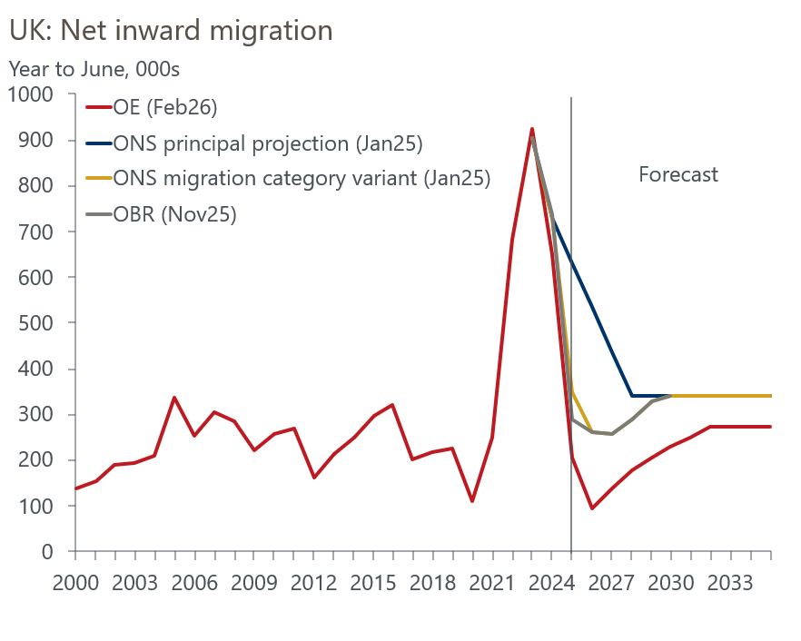
Sources: Oxford Economics, ONS

In our most recent forecast update, we cut our assumption for net inflows over the year to mid-2026 to just 93,000, which would be the lowest level since 1997. This was in response to recent much lower data on the number of visas granted. Given the prevailing political climate around immigration, we think net inflows are likely to remain low for at least the remainder of the current parliament.
Our new forecast shows the population 1.5mn (2.1%) lower than the ONS principal projection in 2030, and 660,000 below its migration category variant, which assumed a faster drop in net inflows. The OBR bases its forecast on an adapted version of the migration category variant, so it's likely to have to cut its assumptions at some point. If the OBR brings its migration assumptions into line with ours, it would imply cutting its forecast for the level of potential output in 2029-2030, the target year for the fiscal rules, by 1ppt. Applying this change to the OBR's ready reckoner suggests it would add around £19bn (0.5% of GDP) to borrowing on the current budget measure in 2029-2030, wiping out the bulk of the Chancellor's margin for error.
The next set of official population projections is due to be published in April, and the OBR is likely to use these assumptions as the basis for its forecasts for this autumn's Budget. But it's possible that the OBR might flag the likelihood of a downgrade when it publishes its interim forecast update on March 3. The extent to which the ONS will cut its population projections is uncertain, and equally the OBR has a lot of leeway on how it incorporates the new projections into its forecast. But this issue certainly has the potential to constrain any new PM in their policy choices.
The week's only major data release added to the chances that the OBR will also have to downgrade its near-term growth forecast. GDP rose by just 0.1% q/q in Q4 2025, matching the underwhelming performance of Q3. The trajectory of the monthly data and the ongoing problem of residual seasonality suggests that Q1 2026 will be a bit stronger. But unless there are some favourable data revisions, there will need to be a marked step up in the underlying pace of growth if the UK is to get close to achieving the 1.4% growth rate that the OBR anticipates for this year.
The Q4 expenditure breakdown reinforced our pessimism that such a pickup will take place. Government consumption and investment contributed 0.5ppts to q/q growth, with the private sector exerting a drag of 0.4ppts. This continued the miserable private sector performance of recent years – since the end of 2022, GDP has grown by 2.4% and the private sector has contributed just 0.2ppts (Chart 2).
Chart 2: Since the end of 2022, GDP growth has been heavily reliant on the public sector
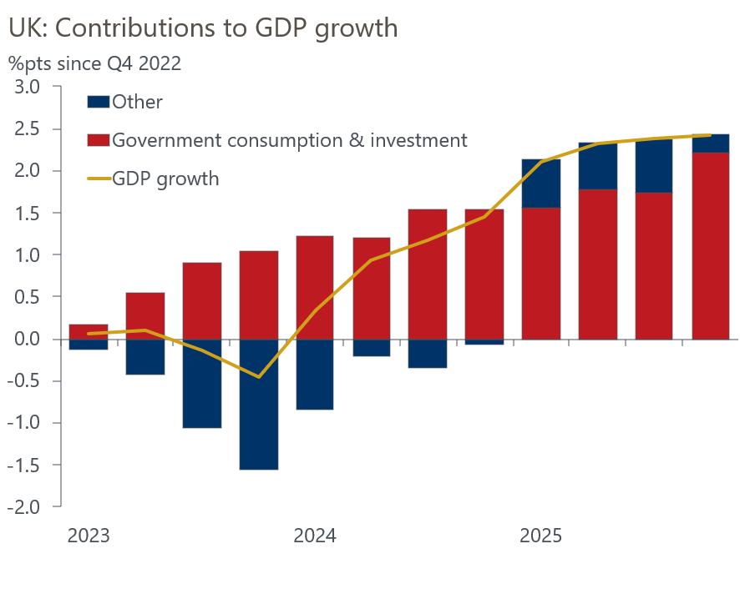
Source: Oxford Economics calculations using data from Haver Analytics
Though the bulk of the Q4 drag came from the volatile trade elements, domestically orientated sectors scarcely provided any cause for optimism. Consumer spending underwhelmed again, growing just 0.2% q/q, while business investment fell sharply, more than reversing Q3's solid gain. Given the headwinds from slowing real income growth and weak corporate profitability, the near-term outlook for both components of demand looks soft. While we should be able to rely on another solid contribution from the public sector this year, the lack of a sustainable private sector growth driver suggests we're unlikely to see GDP growth top 1% in 2026.

The week ahead
Tuesday's labour market release will complete the picture for Q4 and 2025 as a whole. Pay growth slowed progressively through H2 2025, reflecting a combination of fading momentum and base effects. Pay rose strongly in December 2024, creating another strong base effect, and we expect this to result in headline (three-month average of the annual rate) total pay growth slowing to 4.5% in December, with regular pay growth dropping to 4.2%.
On the quantities side, both employment and unemployment have risen in recent months. But with recent single month outturns showing smaller increases in joblessness, we think the three-month average will have stayed at 5.1% in the three months to December.
Though CPI inflation ticked up in December, we expect this to prove a blip. Weekly data from the Department for Energy Security and Net Zero suggests petrol prices fell by 2% between December and January, in contrast to a 0.8% increase between those months a year earlier. There will also be strong negative base effects from last year's imposition of VAT on private school fees and a high January 2025 outturn for food prices. We think that CPI inflation dropped to 3.1% in January.
After falls in three of the previous four months, retail sales rose in December, and we think there's a good chance there was another small gain in January. The main impulse should come from the non-food sector, where sales slumped in January, and we expect this to more than offset a fall in fuel sales. We forecast a 0.1% m/m increase in sales in January.
Table 1: Week ahead calendar
Date | Events | Period | Measure | Unit | Previous | Forecast
Feb 17 | LFS unemployment | Oct-Dec | Rate | % | 5.1 | 5.1
Feb 17 | Average earnings (total pay) | Dec | 3m, y/y | % | 4.7 | 4.5
Feb 17 | Average earnings (regular pay) | Dec | 3m, y/y | % | 4.5 | 4.2
Feb 18 | CPI inflation | Jan | m/m | % | 0.4 | -0.4
Feb 18 | CPI inflation | Jan | y/y | % | 3.4 | 3.1
Feb 18 | RPI inflation | Jan | m/m | % | 0.7 | -0.2
Feb 18 | RPI inflation | Jan | y/y | % | 4.2 | 4.1
Feb 18 | Producer input prices | Jan | m/m | % | -0.2 | 0.1
Feb 18 | Producer input prices | Jan | y/y | % | 0.8 | -0.1
Feb 18 | Producer output prices | Jan | m/m | % | 0.0 | 0.1
Feb 18 | Producer output prices | Jan | y/y | % | 3.4 | 2.8
Feb 18 | Land Registry house prices | Dec | y/y | % | 2.5 | 2.2
Feb 20 | Public finances | Jan | PSNB | £bn | 11.6 | -19.0
Feb 20 | Retail sales inc fuel | Jan | m/m | % | 0.4 | 0.1
Feb 20 | Retail sales inc fuel | Jan | y/y | % | 2.5 | 2.8
Feb 20 | S&P Global manufacturing | Feb | PMI | % bal | 51.8 | 52.0
Feb 20 | S&P Global services | Feb | PMI | % bal | 54.0 | 54.2
Feb 20 | S&P Global composite | Feb | PMI | % bal | 53.7 | 53.9
Source: Oxford Economics

Key forecasts
Table 2: UK forecast overview
(Annual percentage changes unless specified)
 | 2023 | 2024 | 2025 | 2026 | 2027 | 2028
GDP | 0.3 | 1.1 | 1.4 | 0.9 | 1.3 | 1.4
Private consumption | -0.3 | -0.1 | 0.9 | 1.1 | 1.1 | 1.3
Fixed investment | 0.5 | 1.7 | 3.2 | 0.9 | 2.1 | 2.1
Government consumption | 2.1 | 2.9 | 1.8 | 2.1 | 1.7 | 1.4
Exports of goods and services | -2.3 | 1.4 | 2.1 | 0.9 | 1.1 | 1.3
Imports of goods and services | -1.6 | 2.7 | 4.2 | 0.4 | 1.2 | 1.4
Industrial production | -2.6 | -1.3 | 0.5 | 0.6 | 1.1 | 1.2
Consumer prices | 7.3 | 2.5 | 3.4 | 2.5 | 2.6 | 2.4
Unemployment rate (%) | 4.1 | 4.3 | 4.8 | 5.2 | 5.0 | 4.7
Current a/c balance (% of GDP) | -3.6 | -3.0 | -2.9 | -3.0 | -2.8 | -2.6
Government balance (% of GDP) | 5.2 | 5.3 | 5.0 | 3.9 | 3.3 | 2.8
Central bank policy rate (%, EOP) | 5.25 | 4.75 | 3.75 | 3.25 | 3.00 | 2.75
10yr govt. bond yield (%, EOP) | 3.54 | 4.57 | 4.47 | 4.38 | 3.90 | 3.64
Exchange rate (US$ per £, EOP) | 1.27 | 1.25 | 1.35 | 1.31 | 1.30 | 1.30
Exchange rate (euro per £, EOP) | 1.15 | 1.21 | 1.15 | 1.11 | 1.10 | 1.10
Source: Oxford Economics
Table 3: Quarterly forecasts for the UK
 | 2025 |  |  |  | 2026
 | Q1 | Q2 | Q3 | Q4 | Q1 | Q2 | Q3 | Q4
GDP (% year) | 1.8 | 1.4 | 1.3 | 1.1 | 0.7 | 0.7 | 0.9 | 1.1
CPI inflation (% year) | 2.8 | 3.5 | 3.8 | 3.4 | 3.0 | 2.2 | 2.4 | 2.5
Bank Rate (%, EOP) | 4.50 | 4.25 | 4.00 | 3.75 | 3.75 | 3.50 | 3.50 | 3.25
10yr gilt yield (%, EOP) | 4.70 | 4.48 | 4.70 | 4.47 | 4.50 | 4.50 | 4.46 | 4.38
US$ per £ (EOP) | 1.29 | 1.37 | 1.35 | 1.35 | 1.35 | 1.33 | 1.32 | 1.31
Euro per £ (EOP) | 1.20 | 1.17 | 1.15 | 1.15 | 1.15 | 1.13 | 1.12 | 1.11
Source: Oxford Economics

Latest Country Economic Forecast:
January 22, 2026

Recent publications

Data Insights
GDP rounded out last year on a quiet note
January's PMIs probably overstate the economy's momentum
Manufacturing sector made a steady start to the year
Surprise fall in mortgage approvals in December
January PMI looks too good to be true

Research Briefings
Lower immigration will hit growth and raise borrowing
Dovish hold prepares the ground for more easing
Would a change in Labour's leadership affect economic policy?
Forecasters' Mailbag – Questions from our conference
MPC preview – Rates on hold amid signs of pay stickiness

Contacts

Oxford Economics' UK team
- Andrew Goodwin - Chief UK Economist - agoodwin@oxfordeconomics.com
- Edward Allenby - Senior UK Economist - eallenby@oxfordeconomics.com

